**ABSTRACT**

# Electronic Ticket Machine

The Kerala State Road Transport Corporation is introducing ticket machines on buses. The ticket machines would end the use of the hefty 1.5-kg ticket racks carried by KSRTC conductors. It would also end the practice of tearing out tickets and marking fare stages.

Instead, the KSRTC conductor would just have to key in the details about the fare stage and the ticket machine would print out the ticket. The machine weighs only 800 grams and is convenient to carry. The parameters are almost like that of a railway ticket, the only difference being that the machine is portable.

The machine can print out 2,300 tickets, including the journey report in order to facilitate inspection by the corporation's checking inspectors. Each machine costs Rs. 10,000 to Rs. 12,000. The KSRTC has budgeted Rs. 2 cores for this innovative step which would have the support of the Information Technology Department. In old days the KSRTC was spending Rs. 85 lakhs on printing tickets. The ticket machines would help prevent loss on account of malpractice. It would also help in providing adequate data to the corporation, particularly with regard to the boarding of passengers from fare stages and important points. This would help the corporation prepare and organize its schedules more efficiently on the basis of traffic demand. Besides, it would provide data on concessions given to various sections. Another additional feature is that the data in the ticket machine could be fed into the computer. More over the depots of the corporation would be fully computerized so we want to add some other modules in our domain for depot’s verification.

1. **OVERVIEW OF THE PROJECT**
   1. **INTRODUCTION**

**Electronic Bus Ticketing**

The ticket machines would end the use of the hefty 1.5-kg ticket racks carried by conductors. It would also end the practice of tearing out tickets and marking fare stages. The Conductor would just have to key in the details about the fare stage and the ticket machine would print out the ticket. The machine weighs only 800 grams and is convenient to carry. The parameters are almost like that of a railway ticket, the only difference being that the machine is portable. The machine can print out 2,300 tickets, including the journey report in order to facilitate inspection by the corporation's checking inspectors. The ticket machines would help prevent loss on account of malpractice. It would also help in providing adequate data to the corporation, particularly with regard to the boarding of passengers from fare stages and important points. This would help the corporation prepare and organize its schedules more efficiently on the basis of traffic demand. Besides, it would provide data on concessions given to various sections. Another additional feature is that the data in the ticket machine could be fed into the computer. More over the depots of the corporation would be fully computerized so we want to add some other modules in our domain for depot’s verification.

This project is modularized as the following:

* **Management of Route**
* **Trip Details**
* **Bus Details**
* **Bus Stops**
* **Bus Ticketing**

**1. Management of Routes**

This module include information about how we can Manage the routes for a particular bus services so In the case of Route management module we must know the details about route number, number of stops ,fare stages and running time of the particular bus more over we want to manipulate and stored these information successfully.

**2. Trip information**

Each journey is identified as a trip. Each ticket must contain the trip no so that calculation of passenger can be done easily. Here in this section we want to know start time and route no of the bus this information can be manipulate and stored successfully.

**3. Bus Detail**

In this module all bus details are stored and manipulated, in bus detail module contains minimum charge, type, depot, fare increment, bus number, and passenger’s states (child or adult) are manipulate and stored.

4. **Bus Stops**

Bus Stops module includes information about what are the main bus stops of a particular bus. This module connected to the route of the bus and it is used to store stop number, stop name and fare stages and Route number

**5. Bus Ticketing**

Ticketing is the most important module in this Project which uses all the tables together and calculates fare for the passengers. Venting the tickets is done using the route number, bus type, beginning stop, end stop, ticket number, persons(Adult/child)rate, date and time also we want to print the all these information. In order to do the calculation data has to be pulled out from stops, bus, trip and route. Number of passengers & the states are entered by the Venter and to produce the tickets.

1. **SYSTEM STUDY AND ANALYSIS**

**2.1 INTRODUCTION**

System analysis is a process of gathering and interpreting facts, diagnosing problems and the information to recommend improvements on the system. It is a problem solving activity that requires intensive communication between the system users and system developers. System analysis or study is an important phase of any system development process. The system is studied to the minutest detail and analyzed. The system analyst plays the role of the interrogator and dwells deep into the working of the present system. The system is viewed as a whole and the input to the system are identified. The outputs from the organizations are traced to the various processes. System analysis is concerned with becoming aware of the problem, identifying the relevant and decisional variables, analyzing and synthesizing the various factors and determining an optimal or at least a satisfactory solution or program of action.

      A detailed study of the process must be made by various techniques like interviews, questionnaires etc. The data collected by these sources must be scrutinized to arrive to a conclusion. The conclusion is an understanding of how the system functions. This system is called the existing system. Now the existing system is subjected to close study and problem areas are identified. The designer now functions as a problem solver and tries to sort out the difficulties that the enterprise faces. The solutions are given as proposals. The proposal is then weighed with the existing system analytically and the best one is selected. The proposal is presented to the user for an endorsement by the user. The proposal is reviewed on user request and suitable changes are made. This is loop that ends as soon as the user is satisfied with proposal.

      Preliminary study is the process of gathering and interpreting facts, using the information for further studies on the system. Preliminary study is problem solving activity that requires intensive communication between the system users and system developers. It does various feasibility studies. In these studies a rough figure of the system activities can be obtained, from which the decision about the strategies to be followed for effective system study and analysis can be taken.

   Here in the project E-Ticketing, a detailed study of existing system is carried along with all the steps in system analysis. An idea for creating a better project was carried and the next steps were followed.

**2.2 FEASIBILITY STUDY**

An important outcome of the preliminary investigation is the determination that the system requested is feasible. Feasibility study is carried out to select the best system that meets the performance requirements.

Feasibility study is both necessary and prudent to evaluate the feasibility of the project at the earliest possible time. It involves preliminary investigation of the project and examines whether the designed system will be useful to the organization. Months or years of effort, thousand for millions of money and untold professional embarrassment can be averted if an in-conceived system is recognized early in the definition phase.

The different types of feasibility are: Technical feasibility, Operational feasibility, Economical feasibility.

**2.2.1 Technical feasibility**

Technical Feasibility deals with the hardware as well as software requirements. Technology is not a constraint to type system development. We have to find out whether the necessary technology, the proposed equipments have the capacity to hold the data, which is used in the project, should be checked to carryout this technical feasibility.

The technical feasibility issues usually raised during the feasibility stage of investigation includes these

* This software is running in windows 2000 Operating System, which can be easily installed.
* The hardware required is Pentium based server.
* The system can be expanded.

**2.2.2 Behavioral Feasibility**

This feasibility test asks if the system will work when it is developed and installed.

Operational feasibility in this project:

* The proposed system offers greater level of user-friendliness.
* The proposed system produces best results and gives high performance. It can be implemented easily .So this project is operationally feasible.

**2.2.3 Economical feasibility**

Economical Feasibility deals about the economical impact faced by the organization to implement a new system. Financial benefits must equal or exceed the costs. The cost of conducting a full system, including software and hardware cost for the class of application being considered should be evaluated. Economic Feasibility in this project:

* The cost to conduct a full system investigation is possible.
* There is no additional manpower requirement.
* There is no additional cost involved in maintaining the proposed system.

**2.3 SYSTEM SPECIFICATION**

**2.3.1 Hardware Specification**

Processor : Intel Pentium IV 2.4 GHZ or above

Clock speed : 500 MHZ

System bus : 32 bits

RAM : 256MB of RAM

HDD : 40 GB or higher

Monitor : SVGA COLOR

Keyboard : 108 keys

Mouse : 2 button mouse

**2.3.2** **Software Specification**

OS : MS WINDOWS XP SP2

Front End : Visual Basic 6.0

Back End : MS ACCESS 2003

**2.4 EXISTING SYSTEM**

Existing system refers to the system that is being followed till now. The existing system requires more computational time, more manual calculations, and the complexity involved in Selection of features is high. The other disadvantages are lack of security of data, Deficiency of Data accuracy, Time consuming etc. To avoid all these limitations and make the working more accurately the system needs to be computerized.    Here in the Electronic bus ticketing, a detailed study of existing system is carried along with all the steps in system analysis.

**2.4.1 Draw backs of existing system.**

      Here in the Electronic bus ticketing, a detailed study of existing system is carried along with all the steps in system analysis. An idea for creating a better project was carried and the next steps were followed.

* Lack of security of data.
* More man power.
* Time consuming.
* Consumes large volume of pare work.
* Needs manual calculations.
* No direct role for the higher officials.
* Damage of machines due to lack of attention.

To avoid all these limitations and make the working more accurately the system needs to be computerized.

**2.5 PROPOSED SYSTEM**

The aim of proposed system is to develop a system of improved facilities. The proposed system can overcome all the limitations of the existing system. The system provides proper security and reduces the manual work. The existing system has several disadvantages and many more difficulties to work well. The proposed system tries to eliminate or reduce these difficulties up to some extent. The proposed system will help the user to reduce the workload and mental conflict. The proposed system helps the user to work user friendly and he can easily do his jobs without time lagging.

**2.5.1 Advantages of Proposed System**

The system is very simple in design and to implement. The system requires very low system resources and the system will work in almost all configurations. It has got following features

* Ensure data accuracy.
* Minimize manual data entry.
* Minimum time needed for the various processing
* Greater efficiency
* Better Service
* Minimum time required
* The ticket machines would help prevent loss on account of malpractice
* It would also help in providing adequate data to the corporation, particularly with regard to boarding of passengers from fare stages and important points
* This would help the corporation prepare and organize its schedules more efficiently on the basis of traffic demand.
* It would provide data on concessions given to various sections.
* Another additional feature is that the data in the ticket machine could be fed into the computer.

3. SYSTEM DESIGN

**3.1 INTRODUCTION**

System Design is the most creative and challenging phase in the system life cycle. Design is the first step into the development phase for any engineered product or system. Design is a creative process. A good design is the key to effective system. System design is a solution *how to approach* the creation of a new system. System design transforms a logic representation of what is required to do into the physical specification. The specification is converted into physical reality during development.

**3.2 LOGICAL DESIGN**

The logical flow of a system and define the boundaries of a system. It includes the following steps:

* Reviews the current physical system – its data flows, file content, volumes, frequencies etc.
* Prepares output specifications – that is, determines the format, content and Frequency of reports.
* Prepares input specifications – format, content and most of the input functions.
* Prepares edit, security and control specifications.
* Specifies the implementation plan.
* Prepares a logical design walk through of the information flow, output, input, controls and implementation plan.
* Reviews benefits, costs, target dates and system constraints.

**3.3 PHYSICAL DESIGN**

Physical system produces the working systems by define the design specifications that tell the programmers exactly what the candidate system must do. It includes the following steps.

* Design the physical system.
* Specify input and output media.
* Design the database and specify backup procedures.
* Design physical information flow through the system and a physical design Walk through.
* Plan system implementation.
* Prepare a conversion schedule and target date.
* Determine training procedures, courses and timetable.
* Devise a test and implementation plan and specify any new hardware/software.
* Update benefits , costs , conversion date and system constraints

**Design/Specification activities**

* Concept formulation.
* Problem understanding.
* High level requirements proposals.
* Feasibility study.
* Requirements engineering.
* Architectural design.

**3.4 INPUT DESIGN**

Input Design deals with what data should be given as input, how the data should be arranged or code, the dialog to guide the operating personnel in providing input, methods for preparing input validations and steps to follow when error occur. Input Design is the process of converting a user-oriented description of the input into a computer-based system. This design is important to avoid errors in the data input process and show the correct direction to the management for getting correct information from the computerized system. It is achieved by creating user-friendly screens for the data entry to handle large volume of data. The goal of designing input is to make data entry easier and to be free from errors. The data entry screen is designed in such a way that all the data manipulates can be performed. It also provides record viewing facilities.

When the data is entered it will check for its validity. Data can be entered with the help of screens. Appropriate messages are provided as when needed so that the user will not be in maize of instant. Thus the objective of input design is to create an input layout that is easy to follow.

In this project, the input design consists of a log in screen, tab for compression/ decompression, source and destination browsing button, a menu list for selecting the algorithm, Compress/Decompress option, compress/decompress button.

**3.5 OUTPUT DESIGN**

A quality output is one, which meets the requirements of the end user and presents the information clearly. The objective of output design is to convey information about past activities, current status or projections of the future, signal important events, opportunities, problems, or warnings, trigger an action, confirm an action etc. Efficient, intelligible output design should improve the system’s relationship with the user and helps in decisions making. In output design the emphasis is on displaying the output on a CRT screen in a predefined format. The primary consideration in design of output is the information requirement and objectives of the end users. The major formation of the output is to convey the information and so its layout and design need a careful consideration.

There is an output display screen for showing the compressed/ decompressed file or folder details (Original file size, Compressed/Decompressed file size, distinct characters)

**3.6 DATA FLOW DIAGRAM**

Data flow oriented techniques advocate that the major data items handled by a system must be first identified and then the processing required on these data items to produce the desired outputs should be determined. The DFD (also called as bubble chart) is a simple graphical formalism that can be used to represent a system in terms of input data to the system, various processing carried out on these data, and the output generated by the system. It was introduced by De Macro (1978), Gane and Sarson (1979).The primitive symbols used for constructing DFD’s are:

**Symbols used in DFD**

A *circle* represents a process.

A *rectangle* represents external entity

A *square* defines a source or destination of the system data.

An *arrow* identifies dataflow.

*Double line* with one end closed indicates data store

**Data Flow Diagram**

**Context Diagram**

Administrator

Administrator

Passenger Details details

Administrator

Admin id, password

Route management

Admin details

Bus details

View Bus Details

Login

Verify

Validate

Bus Ticketing

Trip information

Bus Stop

**Level 1 DFD Administrator**

**3.7 DATABASE DESIGN**

A database is an organized mechanism that has the capability of storing information through which a user can retrieve stored information in an effective and efficient manner. The data is the purpose of any database and must be protected.

The database design is a two level process. In the first step, user requirements are gathered together and a database is designed which will meet these requirements as clearly as possible. This step is called Information Level Design and it is taken independent of any individual Database Management System (DBMS).

In the second step, this Information level design is transferred into a design for the specific DBMS that will be used to implement the system in question. This step is called Physical Level Design, concerned with the characteristics of the specific DBMS that will be used. A database design runs parallel with the system design. The organization of the data in the database is aimed to achieve the following two major objectives.

* Data Integrity
* Data independence

**3.8 DATABASE TABLE DESIGN**

**Table Name: - Login**

**Primary key: User Name**

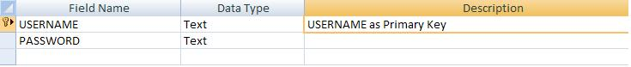

**Table Name: - Route management**

**Primary Key: Routenumber**

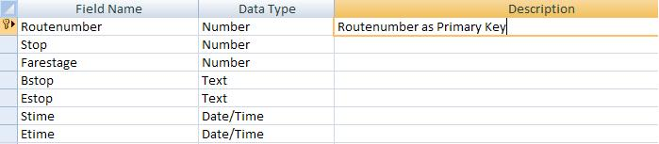

**Table Name: - Busdetails**

**Primary Key: Busnumber**

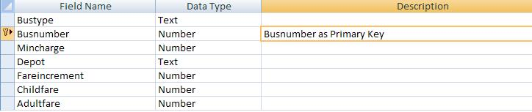

**Table Name: - Busstop**

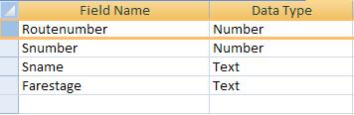

**Table Name: - Trip**

**Primary Key: Routenumber**

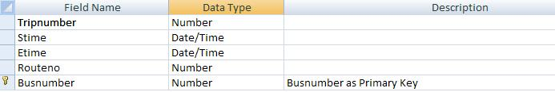

**Table Name: - Ticketing**

**Primary Key: Bus number**

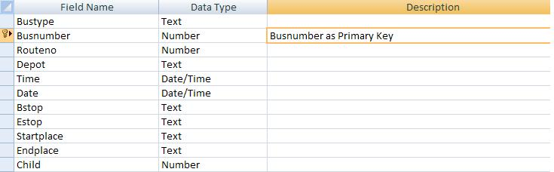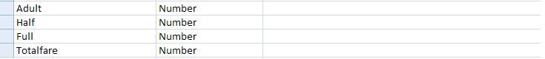

**3.9 SOFTWARE DESCRIPTION**

**3.9.1 Overview of Visual Basic and MS Access**

**The Control Properties**

Before writing an event procedure for the control to response to a user's input, you have to set certain properties for the control to determine its appearance and how it will work with the event procedure. You can set the properties of the controls in the properties window or at runtime.

**Handling some of the common controls**

**The Text Box**

The text box is the standard control for accepting input from the user as well as to display the output. It can handle string (text) and numeric data but not images or pictures. String in a text box can be converted to a numeric data by using the function Val(text). The following example illustrates a simple program that processes the input from the user.

**Example**

In this program, two text boxes are inserted into the form together with a few labels. The two text boxes are used to accept inputs from the user and one of the labels will be used to display the sum of two numbers that are entered into the two text boxes. Besides, a command button is also programmed to calculate the sum of the two numbers using the plus operator. The program use creates a variable sum to accept the summation of values from text box 1 and text box 2.The procedure to calculate and to display the output on the label is shown below. The output is shown in Figure 3.2

Private Sub Command1_Click ()

‘To add the values in text box 1 and text box 2

Sum = Val (Text1.Text) + Val (Text2.Text)

‘To display the answer on label 1

Label1.Caption = Sum

End Sub

**Figure**

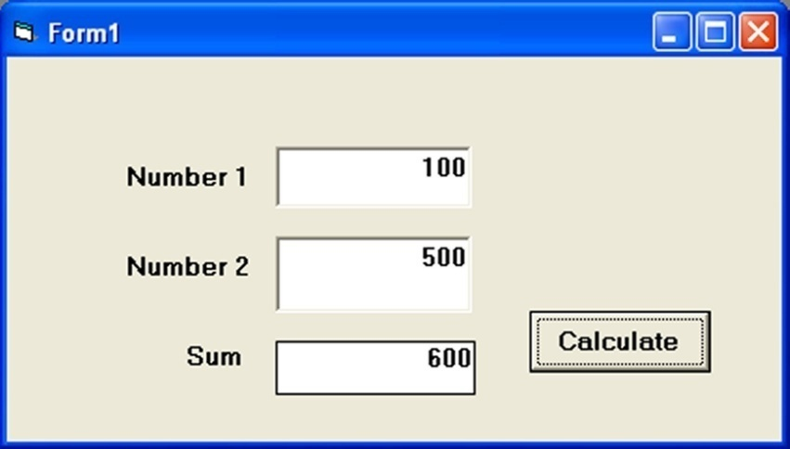

**The Label**

The label is a very useful control for Visual Basic, as it is not only used to provide instructions and guides to the users, it can also be used to display outputs. One of its most important properties is **Caption**. Using the syntax **label. Caption**, it can display text and numeric data . You can change its caption in the properties window and also at runtime.  Please refer to Example 3.1 and Figure 3.1 for the usage of label.

**The Command Button**

The command button is one of the most important controls as it is used to execute commands. It displays an illusion that the button is pressed when the user click on it. The most common event associated with the command button is the Click event, and the syntax for the procedure is

Private Sub Command1_Click ()

Statements

End Sub

**The Picture Box**

The Picture Box is one of the controls that is used to handle graphics. You can load a picture at design phase by clicking on the picture item in the properties window and select the picture from the selected folder. You can also load the picture at runtime using the **LoadPicture** method. For example, the statement will load the picture grape.gif into the picture box.

Picture1.Picture=LoadPicture ("C:\VB program\Images\grape.gif")

You will learn more about the picture box in future lessons. The image in the picture box is not resizable.

**The Image Box**

The Image Box is another control that handles images and pictures. It functions almost identically to the picture box. However, there is one major difference, the image in an Image Box is stretchable, which means it can be resized. This feature is not available in the Picture Box. Similar to the Picture Box, it can also use the LoadPicture method to load the picture. For example, the statement loads the picture grape.gif into the image box.

Image1.Picture=LoadPicture ("C:\VB program\Images\grape.gif")

**The List Box**

The function of the List Box is to present a list of items where the user can click and select the items from the list. In order to add items to the list, we can use the **AddItem method**. For example, if you wish to add a number of items to list box 1, you can key in the following statements

**Example**

Private Sub Form_Load ( )

List1.AddItem “Lesson1”

List1.AddItem “Lesson2”

List1.AddItem “Lesson3”

List1.AddItem “Lesson4”

End Sub

The items in the list box can be identified by the **ListIndex** property, the value of the ListIndex for the first item is 0, the second item has a ListIndex 1, and the second item has a ListIndex 2 and so on

**The Combo Box**

The function of the Combo Box is also to present a list of items where the user can click and select the items from the list. However, the user needs to click on the small arrowhead on the right of the combo box to see the items which are presented in a drop-down list. In order to add items to the list, you can also use the **AddItem method**. For example, if you wish to add a number of items to Combo box 1, you can key in the following statements

**Example**

Private Sub Form_Load ( )

Combo1.AddItem “Item1”

Combo1.AddItem “Item2”

Combo1.AddItem “Item3”

Combo1.AddItem “Item4”

End Sub

**The Check Box**

The Check Box control lets the user  selects or unselects an option. When the Check Box is checked, its value is set to 1 and when it is unchecked, the value is set to 0.  You can include the statements Check1.Value=1 to mark the Check Box and Check1.Value=0 to unmark the Check Box, as well as  use them to initiate certain actions. For example, the program will change the background color of the form to red when the check box is unchecked and it will change to blue when the check box is checked.  You will learn about the conditional statement If….Then….Elesif in later lesson. VbRed and vbBlue are color constants and BackColor is the background color property of the form.

**The Option Box**

The Option Box control also lets the user selects one of the choices. However, two or more Option Boxes must work together because as one of the Option Boxes is selected, the other Option Boxes will be unselected. In fact, only one Option Box can be selected at one time. When an option box is selected, its value is set to “True” and when it is unselected; its value is set to “False”. In the following example, the shape control is placed in the form together with six Option Boxes. When the user clicks on different option boxes, different shapes will appear. The values of the shape control are 0, 1, and 2,3,4,5 which will make it appear as a rectangle, a square, an oval shape, a rounded rectangle and a rounded square respectively.

**Example**

Private Sub Option1_Click ( )

Shape1.Shape = 0

End Sub

Private Sub Option2_Click()

Shape1.Shape = 1

End Sub

Private Sub Option3_Click()

Shape1.Shape = 2

End Sub

Private Sub Option4_Click()

Shape1.Shape = 3

End Sub

Private Sub Option5_Click()

Shape1.Shape = 4

End Sub

Private Sub Option6_Click()

Shape1.Shape = 5

End Sub

**The Drive List Box**

The Drive ListBox is for displaying a list of drives available in your computer. When you place this control into the form and run the program, you will be able to select different drives from your computer as shown in Figure 3.3

**The Directory List Box**

The Directory List Box is for displaying the list of directories or folders in a selected drive. When you place this control into the form and run the program, you will be able to select different directories from a selected drive in your computer as shown in Figure 3.4

**The File List Box**

The File List Box is for displaying the list of files in a selected directory or folder. When you place this control into the form and run the program, you will be able to shown the list of files in a selected directory as shown in Figure 3.5

You can coordinate the Drive List Box, the Directory List Box and the File List Box to search for the files you want. The procedure will be discussed in later lessons.

**MS ACCESS 2003**

Microsoft Access is a powerful program to create and manage your databases. It has many built in features to assist you in constructing and viewing your information. Access is much more involved and is a more genuine database application than other programs such as Microsoft Works.

The keywords involved in the process are: *Database File, Table, Record, Field, Data-type*. Here is the Hierarchy that Microsoft Access uses in breaking down a database.

|  |
| --- |
| Breakdown |
|
|
|

|  |
| --- |
|  |
|  |
|  |
|  |

**Database File**: This is your main file that encompasses the entire database and that is saved to your hard-drive or floppy disk.

Example: StudentDatabase.mdb

**Table**:A table is a collection of data about a specific topic. There can be multiple tables in a database.

**Field**: Fields are the different categories within a Table. Tables usually contain multiple fields.

**Datatypes**:Datatypes are the properties of each field. A field only has 1 datatype.

FieldName) Student LastName

Datatype) Text

**Starting Microsoft Access**

* Two Ways
  1. Double click on the Microsoft Access icon on the desktop.   
     
  2. Click on Start --> Programs --> Microsoft Access   
     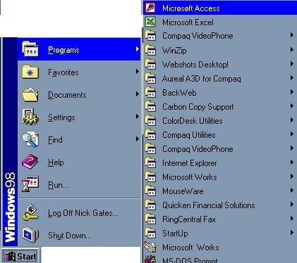

**Creating New, and Opening Existing Databases**

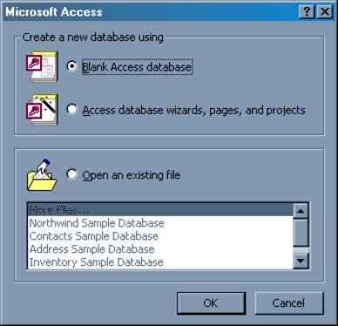

The above picture gives you the option to:

* Create a New Database from scratch
* Use the wizard to create a New Database
* Open an existing database
  + The white box gives you the most recent databases you have used. If you do not see the one you had created, choose the More Files option and hit OK. Otherwise choose the database you had previously used and click OK.
  1. **SYSTEM TESTING AND IMPLEMENTATIONS**

**4.1 CODING**

**Progress bar**

Dim i As Integer

Dim x As Integer

Option Explicit

Private Sub Form_KeyPress(KeyAscii As Integer)

Load MDIForm1

MDIForm1.Show

Unload Me

End Sub

Private Sub Form_Load()

'lblVersion.Caption = "Version " & App.Major & "." & App.Minor & "." & App.Revision

File1.FileName = App.Path

x = File1.ListCount

End Sub

Private Sub Frame1_Click()

Unload Me

End Sub

Private Sub Timer1_Timer()

If (Image1.Left <= 6600) Then

Image1.Left = Image1.Left + 50

Else

Image1.Left = 0

End If

If (i <= x) Then

Label1.Caption = File1.List(i)

i = i + 1

Else

Load MDIForm1

MDIForm1.Show

Unload Me

End If

End Sub

**Login**

Private Sub cmdCancel_Click()

MDIForm1.Show

Unload Me

End Sub

Private Sub cmdLogin_Click()

Set rs = con.Execute("select * from login where username='" + cmbUsername.Text + "' and password='" + txtPassword.Text + "'")

If (Not rs.EOF) Then

MsgBox "Login Success"

MDIForm1.route.Enabled = True

MDIForm1.detail.Enabled = True

MDIForm1.stops.Enabled = True

MDIForm1.ticket.Enabled = True

MDIForm1.trip.Enabled = True

MDIForm1.logout.Enabled = True

MDIForm1.newuser.Enabled = True

MDIForm1.cpassword.Enabled = True

MDIForm1.login.Enabled = False

Unload Me

Else

MsgBox "Login Failure! Try Again"

cmbUsername.ListIndex = 0

txtPassword.Text = ""

End If

End Sub

Private Sub Form_Load()

connectdb

Set rs = con.Execute("select * from login")

While (Not rs.EOF)

cmbUsername.AddItem rs(0)

rs.MoveNext

Wend

rs.Close

End Sub

**Main Form**

Private Sub cpassword_Click()

Load frmChangePassword

frmChangePassword.Show

End Sub

Private Sub detail_Click()

Form2.Show

End Sub

Private Sub exit_Click()

Unload Me

End Sub

Private Sub login_Click()

Load Form6

Form6.Show

End Sub

Private Sub logout_Click()

MDIForm1.route.Enabled = False

MDIForm1.detail.Enabled = False

MDIForm1.stops.Enabled = False

MDIForm1.ticket.Enabled = False

MDIForm1.trip.Enabled = False

MDIForm1.logout.Enabled = False

MDIForm1.newuser.Enabled = False

MDIForm1.cpassword.Enabled = False

MDIForm1.login.Enabled = True

End Sub

Private Sub MDIForm_Load()

route.Enabled = False

detail.Enabled = False

stops.Enabled = False

ticket.Enabled = False

trip.Enabled = False

logout.Enabled = False

newuser.Enabled = False

cpassword.Enabled = False

Load Form6

Form6.Show

End Sub

Private Sub route_Click()

Form1.Show

End Sub

Private Sub stops_Click()

Form3.Show

End Sub

Private Sub ticket_Click()

Form4.Show

End Sub

Private Sub trip_Click()

Form5.Show

End Sub

**Route management**

Dim str As String

Private Sub Command1_Click()

End Sub

Private Sub cmdexit_Click()

MsgBox ("Do you want to Exit")

Me.Hide

End Sub

Private Sub Cmdnew_Click()

MsgBox ("Do You want to clear")

Txtrnumber = " "

Txtstops = " "

Txtfare = " "

Txtrun = " "

Txtstime = ""

Txtetime = " "

Txtbstop = " "

Txtestop = " "

End Sub

Private Sub cmdsave_Click()

If Txtrnumber = "" Then

MsgBox "Please Enter the routenumber.", vbInformation

Txtrnumber.SetFocus

Exit Sub

End If

If Txtstops.Text = "" Then

MsgBox "Please Enter the Stop .", vbInformation

Txtstops.SetFocus

Exit Sub

End If

If Txtfare.Text = "" Then

MsgBox "Please Enter the fare .", vbInformation

Txtfare.SetFocus

Exit Sub

End If

If Txtbstop.Text = "" Then

MsgBox "Please Enter the biginning stop .", vbInformation

Txtbstop.SetFocus

Exit Sub

End If

If Txtestop.Text = "" Then

MsgBox "Please Enter the Ending stop .", vbInformation

Txtestop.SetFocus

Exit Sub

End If

If Txtstime.Text = "" Then

MsgBox "Please Enter the Starting time .", vbInformation

Txtstime.SetFocus

Exit Sub

End If

If Txtetime.Text = "" Then

MsgBox "Please Enter the ending time .", vbInformation

Txtetime.SetFocus

Exit Sub

End If

''connectdb

''str = "select * from routemanagement"

''rs.CursorLocation = adUseClient

''rs.Open str, con

''rs.AddNew

''rs.Fields(0) = Val(Txtrnumber.Text)

''rs.Fields(1) = Val(Txtstops.Text)

''rs.Fields(2) = Val(Txtfare.Text)

''rs.Fields(3) = Val(Txtbstop.Text)

''rs.Fields(4) = Val(Txtestop.Text)

''rs.Fields(5) = Val(Txtstime.Text)

''rs.Fields(6) = Val(Txtetime.Text)

''rs.Update

''rs.Close

''MsgBox ("Do you want to save")

con.Execute ("insert into routemanagement values(" + Txtrnumber.Text + "," + Txtstops.Text + "," + Txtfare.Text + ", '" + Txtbstop.Text + "','" + Txtestop.Text + "'," + Txtstime.Text + "," + Txtetime.Text + ")")

MsgBox ("successfully saved")

End Sub

Private Sub Form_Load()

Call connectdb

End Sub

Private Sub txtrnumber_Change()

If KeyAscii = 13 Then

txtnumber.Text = UCase(txtnumber.Text)

txtnumber.SetFocus

End If

End Sub

Private Sub Form_Unload(Cancel As Integer)

con.Close

End Sub

**Bus Stop**

Private Sub cmdexit_Click(Index As Integer)

MsgBox ("Do You want to Exit")

Me.Hide

End Sub

Private Sub Cmdnew_Click()

Txtrnumber = " "

Txtsnumber = " "

txtsname = " "

End Sub

Private Sub Command1_Click()

If (Optyes.Value = True) Then

x = "Yes"

Else

x = "No"

End If

If Txtrouteno.Text = "" Then

MsgBox "Please Enter the routenumber.", vbInformation

Txtrouteno.SetFocus

Exit Sub

End If

If Txtstopno.Text = "" Then

MsgBox "Please Enter the Stop .", vbInformation

Txtstopno.SetFocus

Exit Sub

End If

If Txtstopname.Text = "" Then

MsgBox "Please Enter Stop Name .", vbInformation

Txtstopname.SetFocus

Exit Sub

End If

con.Execute ("insert into busstop values(" + Txtrouteno.Text + "," + Txtstopno.Text + ",'" + Txtstopname.Text + "', '" + x + "' )")

MsgBox ("successfully saved")

End Sub

Private Sub Command2_Click()

MsgBox ("Do you want to Clear")

Txtrouteno = " "

Txtstopno = " "

Txtstopname = " "

End Sub

Private Sub Command3_Click()

Me.Hide

End Sub

Private Sub Form_Load()

connectdb

End Sub

Private Sub Form_Unload(Cancel As Integer)

con.Close

End Sub

Private Sub Optno_Click()

Optno.Enabled = True

Optyes.Visible = False

End Sub

Private Sub Optyes_Click()

Optyes.Enabled = True

Optno.Visible = False

End Sub

**Bus Details**

Private Sub cmdexit_Click()

MsgBox ("Do you want to Exit")

Me.Hide

End Sub

Private Sub Cmdnew_Click()

MsgBox ("Do You want to Clear")

Txtbno = " "

Txtfare = " "

Txtdepot = " "

Txtadultfare = " "

Txtchildfare = " "

Txtmincharge = " "

End Sub

Private Sub cmdsave_Click()

If Cmdbustype = "" Then

MsgBox "Please select bustype.", vbInformation

Cmdbustype.SetFocus

Exit Sub

End If

If Txtbno.Text = "" Then

MsgBox "Please select bus Number.", vbInformation

Txtbno.SetFocus

Exit Sub

End If

If Txtfare.Text = "" Then

MsgBox "Please select bus Fare.", vbInformation

Txtfare.SetFocus

Exit Sub

End If

If Txtdepot.Text = "" Then

MsgBox "Please select bus Depot.", vbInformation

Txtdepot.SetFocus

Exit Sub

End If

If Txtadultfare.Text = "" Then

MsgBox "Please select Adult fare.", vbInformation

Txtadultfare.SetFocus

Exit Sub

End If

If Txtchildfare.Text = "" Then

MsgBox "Please select Child fare.", vbInformation

Txtchildfare.SetFocus

Exit Sub

End If

If Txtmincharge.Text = "" Then

MsgBox "Please select Mincharge.", vbInformation

Txtmincharge.SetFocus

Exit Sub

End If

con.Execute ("insert into busdetails values('" + Cmdbustype.Text + "'," + Txtbno.Text + "," + Txtmincharge.Text + ", '" + Txtdepot.Text + "'," + Txtfare.Text + "," + Txtchildfare.Text + "," + Txtadultfare.Text + ")")

MsgBox ("successfully saved")

End Sub

Private Sub Form_Load()

Call connectdb

Cmdbustype.AddItem "Ordinary"

Cmdbustype.AddItem "Express"

Cmdbustype.AddItem "Super Fast"

Cmdbustype.AddItem "Fast"

Cmdbustype.AddItem "A\C Volvo"

Cmdbustype.AddItem "SemiSleeper Volvo"

Cmdbustype.AddItem "A\C SemiSleeper Volvo"

''Set rs = con.Execute("select * from busdetails")

''While (Not rs.EOF)

''Cmdbustype.AddItem rs(0)

''rs.MoveNext

''Wend

''rs.Close

End Sub

Private Sub Form_Unload(Cancel As Integer)

con.Close

End Sub

**Trip**

Private Sub cmdexit_Click()

MsgBox ("Do You want to Exit")

Me.Hide

End Sub

Private Sub Cmdnew_Click()

MsgBox ("Do You want to Clear")

Txttno.Text = " "

Txtrno.Text = " "

Txtbno.Text = " "

Txtstime.Text = " "

Txtetime.Text = " "

End Sub

Private Sub cmdsave_Click()

If Txttno.Text = "" Then

MsgBox "Please Enter the Trip number.", vbInformation

Txttno.SetFocus

Exit Sub

End If

If Txtrno.Text = "" Then

MsgBox "Please Enter the Route Number .", vbInformation

Txtrno.SetFocus

Exit Sub

End If

If Txtbno.Text = "" Then

MsgBox "Please Enter the bus Number .", vbInformation

Txtbno.SetFocus

Exit Sub

End If

If Txtstime.Text = "" Then

MsgBox "Please Enter the start time .", vbInformation

Txtstime.SetFocus

Exit Sub

End If

If Txtetime.Text = "" Then

MsgBox "Please Enter the End Time .", vbInformation

Txtetime.SetFocus

Exit Sub

End If

con.Execute ("insert into trip values(" + Txttno.Text + "," + Txtstime.Text + ", " + Txtetime.Text + ", " + Txtrno.Text + "," + Txtbno.Text + ")")

MsgBox ("successfully saved")

End Sub

Private Sub Form_Load()

connectdb

End Sub

Private Sub Form_Unload(Cancel As Integer)

con.Close

End Sub

**4.2 TESTING**

Testing is a process of executing a program with the interest of finding an error. A good test is one that has high probability of finding the yet undiscovered error. Testing should systematically uncover different classes of errors in a minimum amount of time with a minimum amount of efforts. Two classes of inputs are provided to test the process

1. A software configuration that includes a software requirement specification, a design specification and source code.
2. A software configuration that includes a test plan and procedure, any testing tool and test cases and their expected results.

Testing is divided into several distinct operations:

**1. Unit Testing**

Unit test comprises of a set tests performed by an individual program prior to the integration of the unit into large system. A program unit is usually the smallest free functioning part of the whole system. Module unit testing should be as exhaustive as possible to ensure that each representation handled by each module has been tested. All the units that makeup the system must be tested independently to ensure that they work as required.

During unit testing some errors were raised and all of them were rectified and handled well. The result was quiet satisfactory and it worked well.

**2. Integration Testing**

Integration testing is a system technique for constructing the program structure while at the same time conducting tests to uncover errors associated with interfacing. The objective is to take unit tested modules and build a program structure that has been dictated by design. Bottom-up integration is the traditional strategy used to integrate the components of a software system into functioning whole. Bottom-up integration consists

of unit test followed by testing of the entire system. A sub-system consists of several modules that communicated with other defined interface.

The system was done the integration testing. All the modules were tested for their compatibility with other modules .They test was almost successful. All the modules coexisted very well, with almost no bugs. All the modules were encapsulated very well so as to not hamper the execution of other modules.

3. Validation Testing

After validation testing, software is completely assembled as a package, interfacing errors that have been uncovered and corrected and the final series of software test; the validation test begins. Steps taken during software design and testing can greatly improve the probability of successful integration in the larger system. System testing is actually a series of different tests whose primary purpose is to fully exercise the compute –based system.

4. Recovery Testing

It is a system that forces the software to fail in a variety of ways and verifies that the recovery is properly performed.

5. Security Testing

It attempts to verify that protection mechanisms built into a system will in fact protect it from improper penetration. The system’s security must of course be tested from in vulnerability form frontal attack.

6. Stress Testing

Stress tools are designed to confront programs with abnormal situations. Stress testing executes a system in a manner that demands resources in abnormal quantity and volume.

7. Black Box Testing

Black box testing is done to find out the following information as shown in below:

1. Incorrect or missing functions.
2. Interface errors.
3. Errors or database access.
4. Performance error.
5. Termination error.

The mentioned testing is carried out successfully for this application according to the user’s requirement specification.

8. Test Data Output

After preparing test data, the system under study is tested using the test data. While testing the system using test data, errors are again uncovered and corrected by using above testing and corrections are also noted for future use.

1. **APPENDIX**

**5.1 Sample Screen Shots**

**Login**

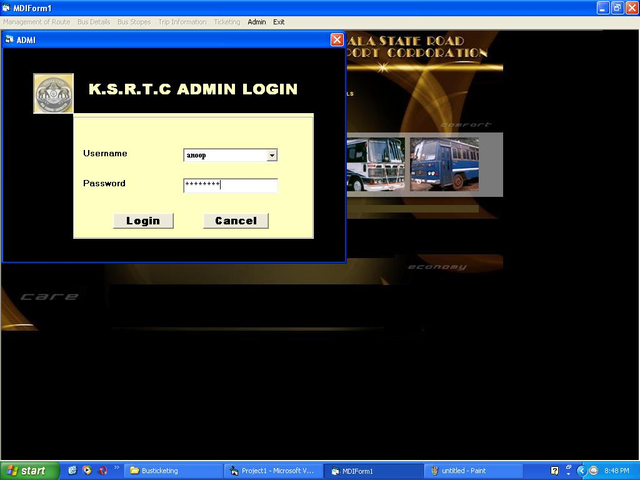

**Main Form**

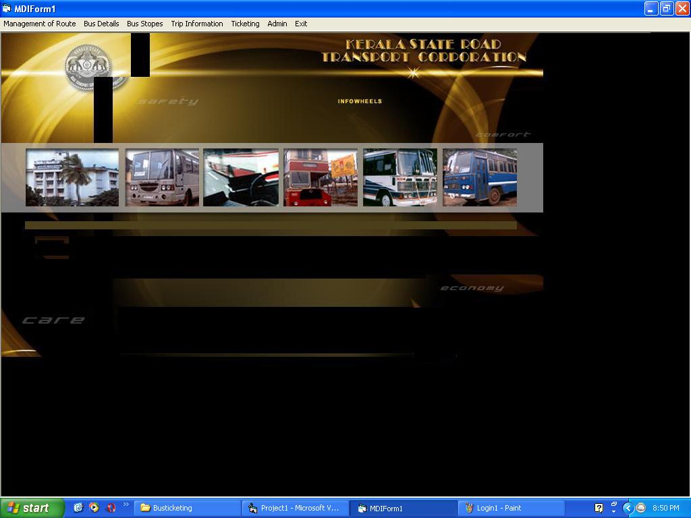

**Route Management**

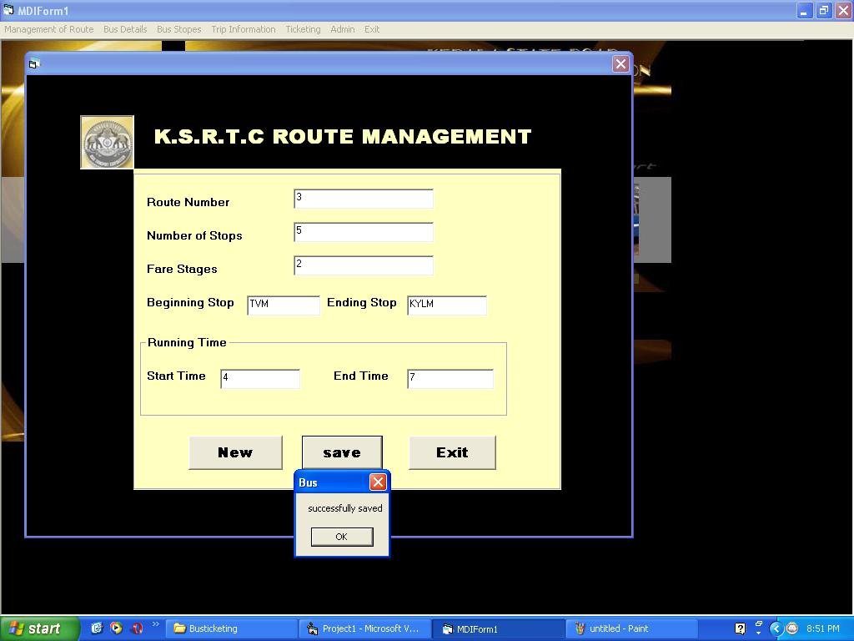

**Bus Stop**

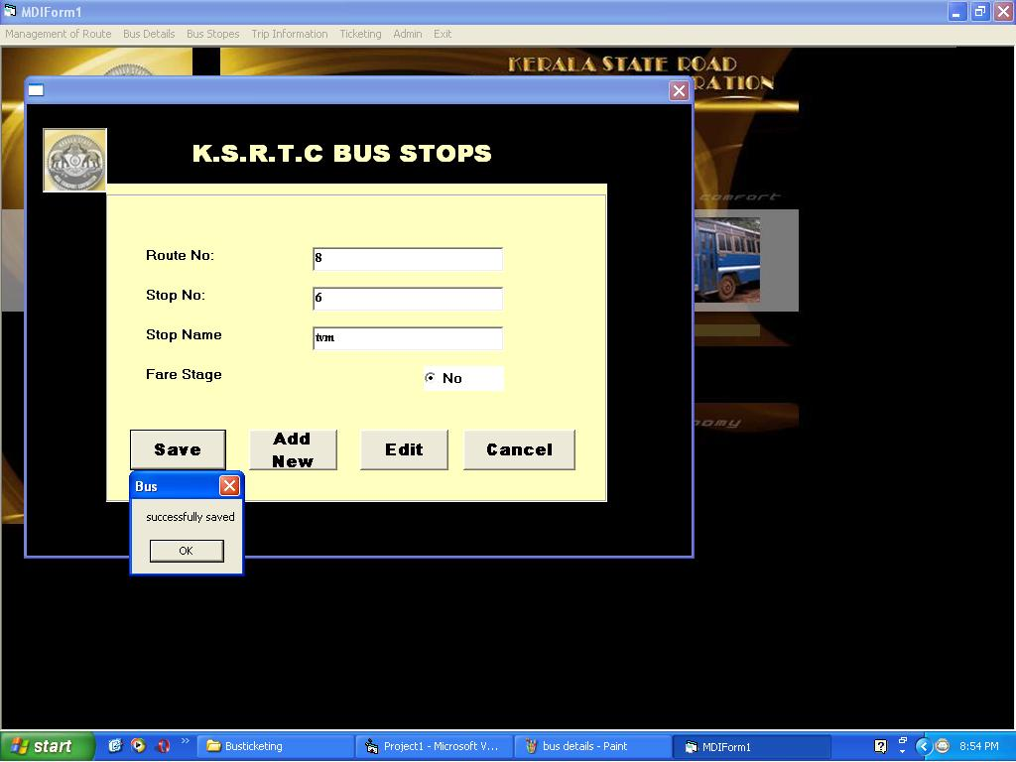

**Bus details**

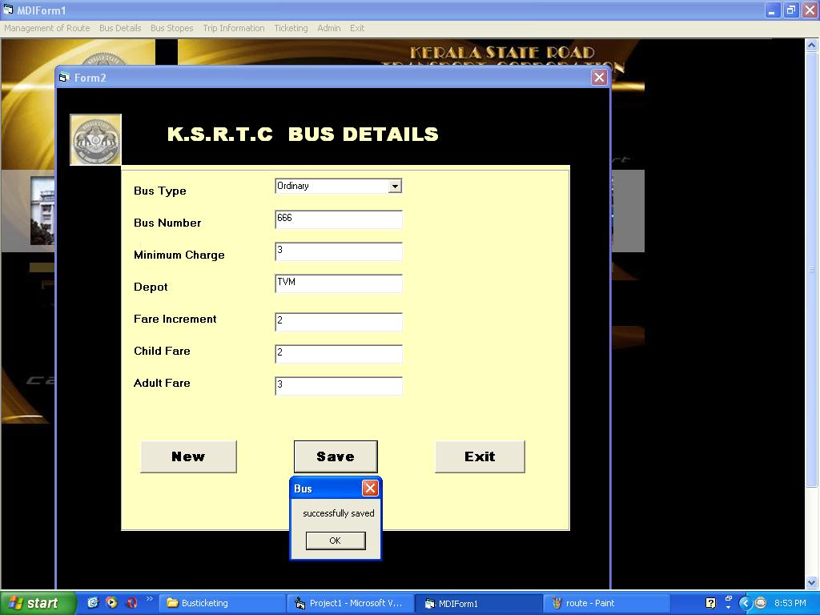

**Trip Information**

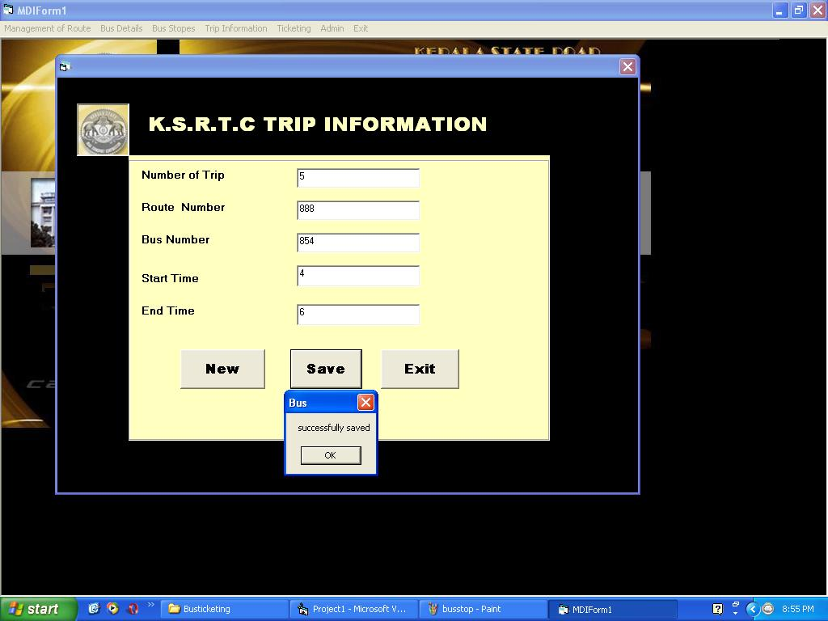

**Ticketing**

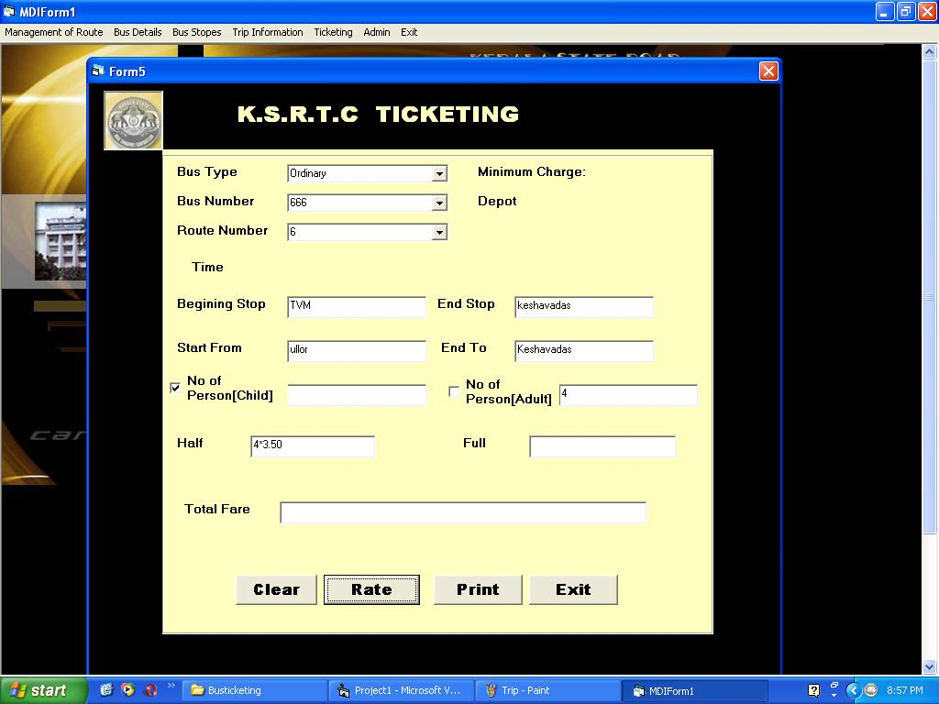

**6. CONCLUSION & FUTURE ENHANCEMENT**

The project E-Ticketing is completed, satisfying the required design specifications. The system provides a user-friendly interface. The software is developed with modular approach. All modules in the system have been tested with valid data and invalid data and everything work successfully. Thus the system has fulfilled all the objectives identified and is able to replace the existing system. The constraints are met and overcome successfully. The system is designed as like it was decided in the design phase. This software has a user-friendly screen that enables the user to use without any inconvenience. The ticket machines would end the use of the hefty 1.5-kg ticket racks carried by conductors. Instead, the conductor would just have to key in the details about the fare stage and the ticket machine would print out the ticket. The machine weighs only 800 grams and is convenient to carry. The parameters are almost like that of a railway ticket, the only difference being that the machine is portable. It would also help in providing adequate data to the corporation, particularly with regard to the boarding of passengers from fare stages and important points. This would help the corporation prepare and organize its schedules more efficiently on the basis of traffic demand. Besides, it would provide data on concessions given to various sections. Another additional feature is that the data in the ticket machine could be fed into the computer.

The application has been tested with live data and has provided a successful result. Hence the software has proved to work efficiently.

**7. BIBLIOGRAPHY**

**BOOKS:**

1. Charles Hampfed (2000) ‘Visual Basic’ University of

Toronto

1. Herbert Schildt (2000) ‘Visual Basic 6.0’ Tata McGraw Hill
2. John Zukowski (2000) ‘Visual Basic 6.0’ ‘BPB Publications
3. Jamie Jaworsky ‘Visual Basic 6.0’Techmedia
4. Stefen Denninger ‘Visual Basic 6.0’Author’s Press
5. Ian Somerville ‘Software engineering’
6. Rajeev mall ‘Software engineering’
7. Elmasri Navathe ‘Fundamentals of database systems’

**ONLINE REFERENCE:**

www.w3schools.com

www.theserverside.com

www.visual.com